Task one

1st website URL;
www.fitnessfirst.co.uk



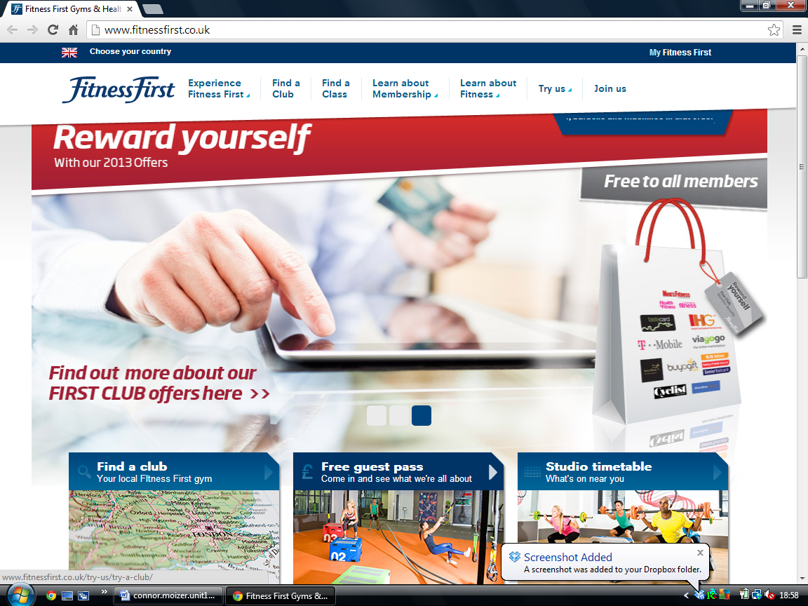

Featchers | usage
rolling Imagers | To catch people attention c1
Hyperlinks with drop downs | to give you more options c2
scrolling banners | to keep up to date with gym news c3
change the country | different parts of the world c4
imagers with text | explains the imagers with text c5
sections | more options c6
Maps | Find where local club is c7

