

0
- Private Sub program1()
- 'Data Declaration
- Dim amount, rate, results As Double

- amount = CDec(txtAmount.Text)
- rate = CDec(txtRate.Text)

- 'Caculate result by multiplying the amount with the exchange rate
- results = amount * rate

- 'Display the result
- txtResult.Text = results
- End Sub
Perpus of program one:
The perpous of the code is to do x y z in this code I have used a some of the following tools like text box so the user can enter 2 numbers then it is calculated and displayed on the screen
When I got the code I tried it and tested it and there was a problem so I tried it in a user form then the code worked

Common words:
Input and output: there are some inputs and outputs on the user form one has three on it and one has one on it where u press the button then the answer popups on the screen as an output box.
Event handler: the event handler is to do with the part of the code that is
Privet Sub Command click button _ 1 () and it can also be written as If Target.Cells.Count > 1 Then Exit Sub Like Line 1 on this is the event handler

Constructs and techneeqs:

Tools I have used in the program the numbers correspond to the numbers on the code.

- Text Boxes
- Output boxes
- Buttons
- User forms

- 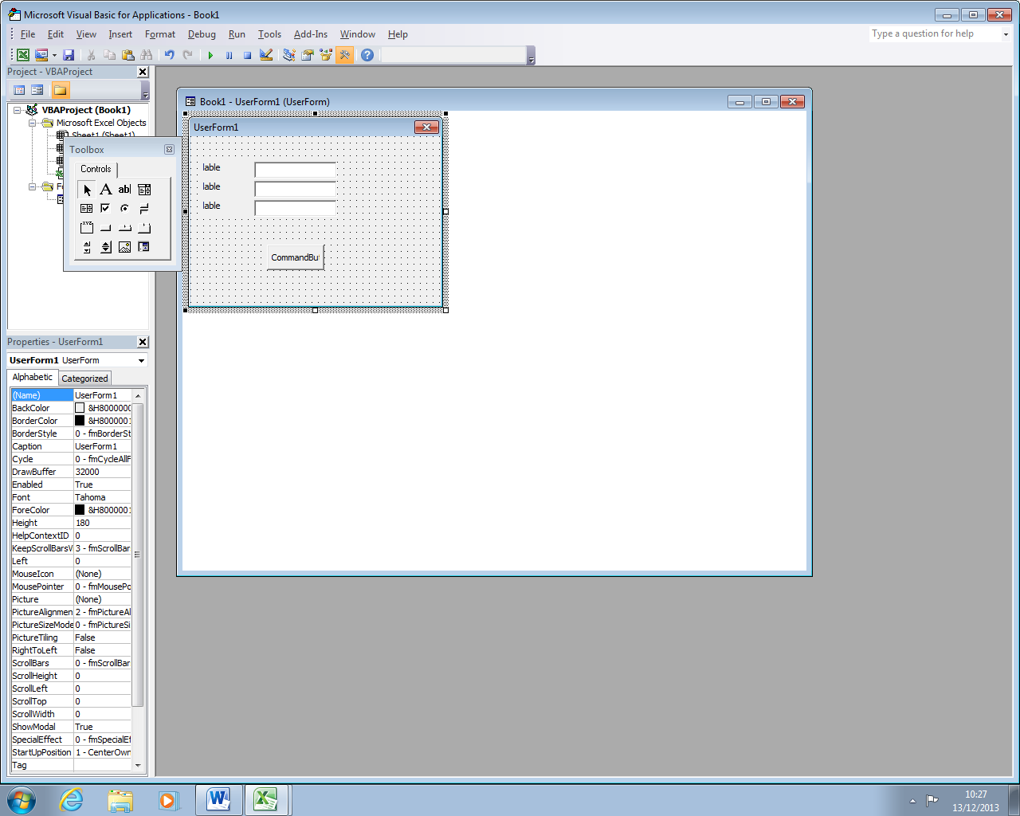

- Private Sub CommandButton1_Click()
- 'Data Declaration
- Dim Sales Total As Integer
- Sales Total = txtSalesTotal.Text
- 'Amount entered into 'Sales Total' Text Box equal or exceeds 150,000 in the n'If Statement', Message Box to display 12,000
- If Sales_Total > 150000 Then
- MsgBox ("Bonus Achieved: 12,000")
- 'Amount entered into 'Sales Total' Text Box ranges from 90,000 to 149,999 in the 'If statement', Message Box to display 8,000.
- Elself Sales_Total >= 90000 And Sales_Total <= 149999 Then
- MsgBox ("Bonus Achieved: 8,000")
- 'Amount entered into "Sales Total' Text Box ranges from 50,000 to 89,999 in the 'If Statement'. Message box to display 5,000.
- Elself Sales_Total >= 50000 And Sales_Total <= 89000 Then
- MsgbBox ("Bonus achieved: 5,000")
- 'Amount entered into 'Sales Total' Text Box less than 50,000 in the 'If Statement', Message Box to display 0.
- Else: MsgBox ("Bouns Achieved: 0")
- End If

- End Sub

The purpose of program 2:
Is to Caculate the sales total for the year
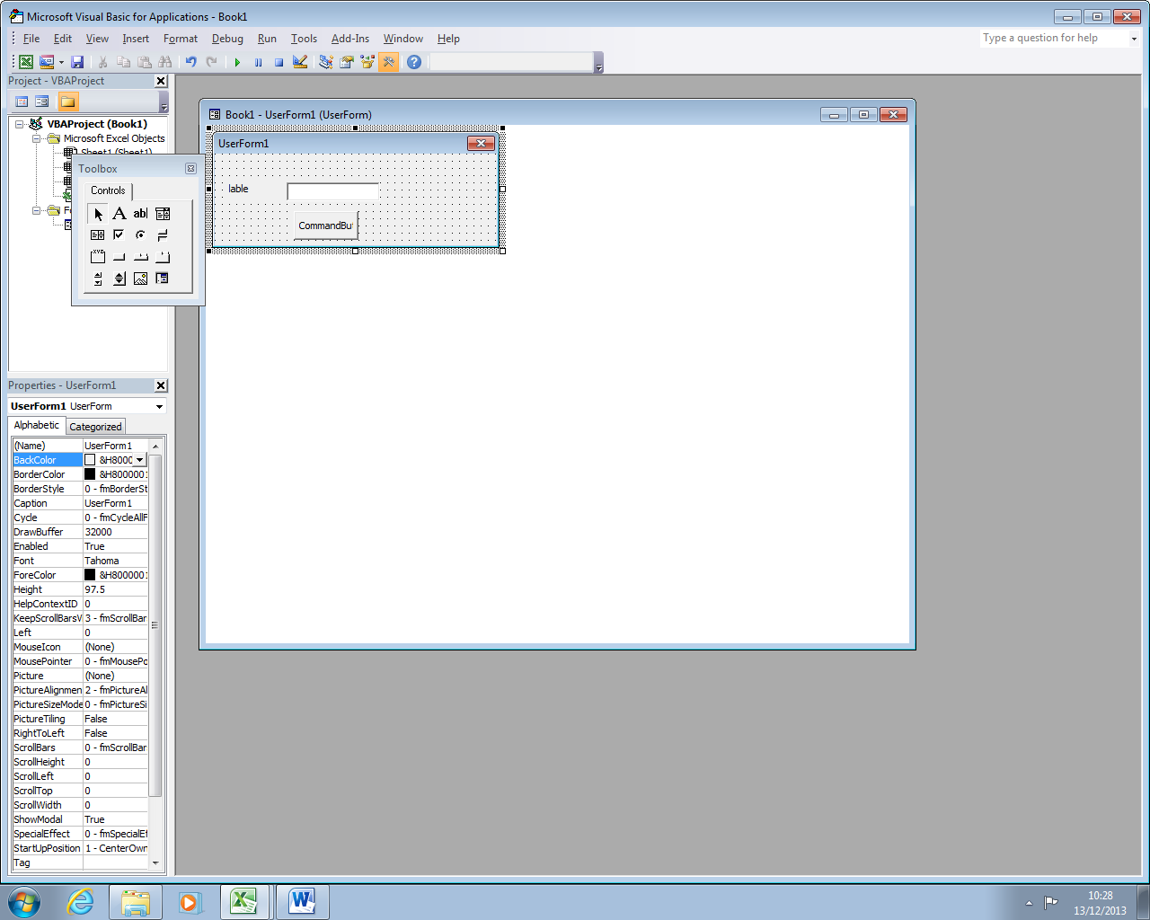
Private Sub CommandButton1_Click ()
- 'Data Declaration
- Dim Sales Total As Integer
- Sales Total = txtSalesTotal.Text
- 'Amount entered into 'Sales Total' Text Box equal or exceeds 150,000 in the n'If Statement', Message Box to display 12,000
- If Sales_Total > 150000 Then
- MsgBox ("Bonus Achieved: 12,000")
- 'Amount entered into 'Sales Total' Text Box ranges from 90,000 to 149,999 in the 'If statement', Message Box to display 8,000.
- Elself Sales_Total >= 90000 And Sales_Total <= 149999 Then
- MsgBox ("Bonus Achieved: 8,000")
- 'Amount entered into "Sales Total' Text Box ranges from 50,000 to 89,999 in the 'If Statement'. Message box to display 5,000.
- Elself Sales_Total >= 50000 And Sales_Total <= 89000 Then
- MsgbBox ("Bonus achieved: 5,000")
- 'Amount entered into 'Sales Total' Text Box less than 50,000 in the 'If Statement', Message Box to display 0.
- Else: MsgBox ("Bouns Achieved: 0")
- End If

- End Sub

This code was broken but then I tried and fixed it and then it worked

Common words:

Inputs and outputs:

There are only one input box and button and when u press the button it displays the answer on the screen

Event handler: the event handler is to do with the part of the code that is
Privet Sub Command click button _ 1 () and it can also be written as If Target.Cells.Count > 1 Then Exit Sub Like Line 1 on this is the event handler

Constructs and techneeqs:

Tools I have used in the program the numbers correspond to the numbers on the code.

- Text Boxes
- Output boxes
- Buttons
- User forms

