Skype
Two personal uses of Skype
- Speaking to friends and family
- Texting when u have no data
Two business uses
- Meetings without leaving the room/building
- Sharing your computer screen with your team
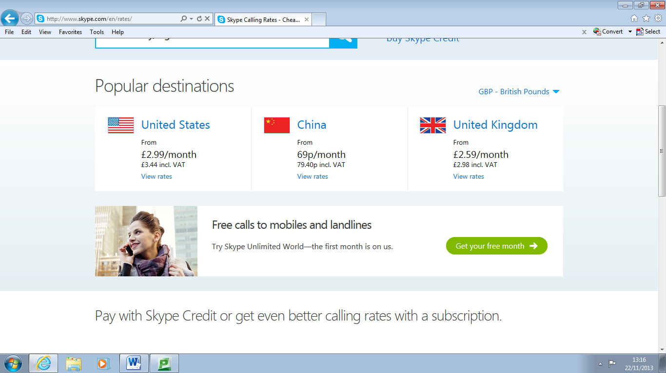
Price to call a home phone/mobile

